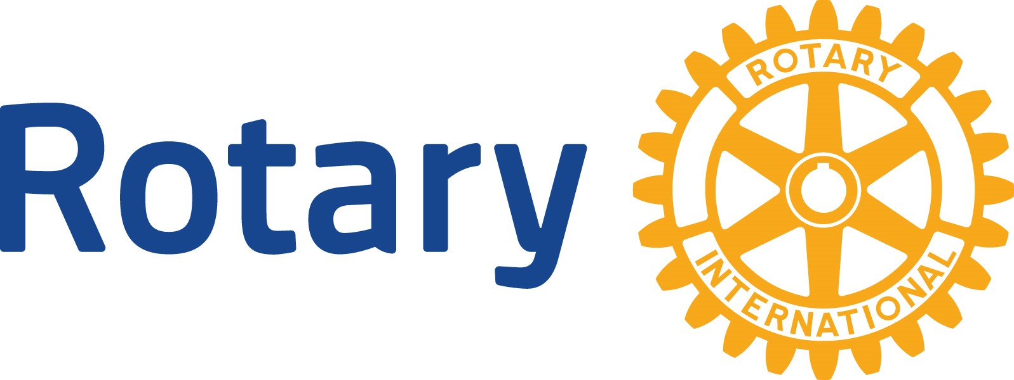
Rotary Club of North East Membership Application Form
Title: ____ Full Name: ______________________________________ | DOB: ________________
Preferred Name: _______________________________

Spouse/Significant other: __________________________________
Mailing Address: __________________________________________________________

_______________________________________________________________
Telephone numbers:
Cell: _________________________________
Business: _____________________________
Other: _______________________________

Preferred e-mail address: __ Residence __ Business
Email: __________________________________________________
Proposed classification (vocation): ___________________________________________
If rejoining or a former Rotarian, list most recent club information:
Previous club name: _____________________________________________________
Dates: ____________________________ Previous Rotary membership ID: _____________
Recent Rotarian (one year or less): __Yes __ No
If an RI program participant or Foundation alumnus/a, list program(s) and dates:
_____________________________________________________________________________ _____________________________________________________________________________ Activities that would enhance consideration as a Rotarian:
_____________________________________________________________________________
____________________________________________________________________________
____________________________________________________________________________

New Member Signature Date

Part B (to be completed by the member)
I hereby certify that I am qualified for active membership by my current or former status as a business, professional, or community leader, or as a Rotary Foundation alumnus/a.
I understand that, if accepted for membership, it will be my duty to exemplify the Object of Rotary in all my daily contacts and activities and to abide by the constitutional documents of Rotary International and the club. I agree to pay the $50 admission fee, which will be credited towards the first dues invoice and to pay annual dues in accordance with the club bylaws. I hereby give permission to the club to publish my name and proposed classification to its membership.
___________________________________________ _________________________

New Member’s Signature Date
Action on Proposal Date
Received by secretary: ________
Former Rotary club contacted (if former Rotarian):
___ In Good Standing __ Not in Good Standing
Submitted to membership committee: _______
Committee decision received: _______
___ Approved ___ Disapproved
Board decision received: ________
___ Approved ___ Disapproved
Proposed to the club: _______
(If any objection has been filed, the board should address the issue at its next meeting.)
Final approval by board: _______
Signed form and admission fee paid: _______
Admitted to membership: ______
Entered into DACdb: ______

To be completed by a club officer
Classification:
_________________________________
If member is a former Rotarian, provide previous club and district information:
Club Name: __________________________
District Number: ______________________
Club ID Number*: _____________________
Rotary membership ID: _________________
*If unsure of number, contact your Club and District Support representative. Find contact information at www.rotary.org.
Mentor assigned to assist with orientation: _____________________________________

“WHY JOIN ROTARY?”

- Friendship: In an increasingly complex world, Rotary provides one of the most basic human needs: The need for friendship and fellowship. It is one of the two reasons why Rotary began in 1905.
- Business Development: The second original reason for Rotary’s beginning is business development. Everyone needs to network and Rotary consists of a cross section of every business community. Its members come from all walks of life. Rotarians help each other and collectively help others.
- Personal Growth and Development: Membership in Rotary continues one’s growth and education in human relations and personal development.
- Leadership Development: Rotary is an organization of leaders and successful people.
Leadership is learning how to motivate, influence and lead leaders.
- Citizenship in the Community: Membership in a Rotary club makes one a better community citizen. The average Rotary club consists of the most active citizens of any community.
- Continuing Education: Each week at Rotary there is a program designed to keep one informed about what is going on in the community, nation and the world. Each meeting provides an opportunity to listen to different speakers and a variety of timely topics.
- Fun: Rotary is fun, a lot of fun! Each meeting is fun, the club projects are fun, the social activities are fun and service is fun!
- Public Speaking Skills: Many individuals who join Rotary are afraid to speak in public. Rotary develops confidence and skill in public communication and the opportunity to practice and perfect these skills.
- Citizenship in the World: Every Rotarian wears a pin that says “Rotary International.”
There are few places on the globe that do not have a Rotary club. Every Rotarian is welcome – even encouraged – to attend any of the 46,000 clubs in over 200 nations and geographical regions. This means instant friends in one’s own community and in the world community.
- Assistance when traveling: Because there are Rotary clubs everywhere, many a
Rotarian in need of a doctor, lawyer, hotel, dentist, advice, etc., while traveling has found assistance through Rotary.
- Entertainment: Every Rotary club and district has parties and activities that provide diversion in one’s business life. Rotary holds conferences, conventions, assemblies and institutes that provide entertainment in addition to Rotary information, education and service.

“WHY JOIN ROTARY?”
- The Development of Social Skills: Every week and at various events and functions,
Rotary develops one’s personality, social skills and people skills. Rotary is for people who like people.
- Family Programs: Rotary provides one of the world’s largest youth exchange programs, high school and college clubs for future Rotarians, opportunities for spouse involvement, and a host of activities designed to help family members in the growth and the development of family values.
- Vocational Skills: Every Rotarian is expected to take part in the growth and development of his or her own profession or vocation, to serve on committees and to teach youth about one’s job or vocation. Rotary helps to make one a better doctor, lawyer, teacher, etc.
- The Development of Ethics: Rotarians practice the 4 – Way Test that governs one’s ethical standards. Rotarians are expected to be ethical in business and personal relationships.
- Cultural Awareness: Around the world, practically every religion, country, culture, race, creed, political persuasion, language, color and ethnic identity is found in Rotary. It is a cross-section of the world’s most prominent citizens from every background. Rotarians become aware of their cultures and learn to love and work with people everywhere. They become better citizens of their countries in the process.
- Prestige: Rotary members are prominent people: Leaders of business, health professions, art, government, sports, military, religion and all disciplines. Rotary is the oldest and most prestigious service club in the world. Its ranks include executives, managers, and professionals – people who make decisions and influence policy.
- The absence of an “Official Creed”: Rotary has no secret handshake, no secret policy, no official creed, no secret meeting or rituals. It is an open society of men and women who simply believe in helping others.
- The Opportunity to Serve: Rotary is a service club. Its business is mankind. Its product is service. Rotarians provide community service to both local and international communities. This is perhaps the best reason for becoming a Rotarian: The chance to do something for someone else and to feel the self-fulfillment that comes in the process. It is richly rewarding.
 | Official Club Name: Rotary Club of North East  We are in District 7630  Club was Established in 1990 | 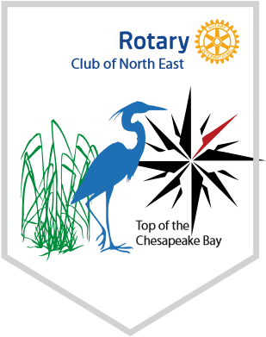
Club Website: http://www.rotaryclubofnortheast.org/
Facebook Page: https://www.facebook.com/northeastrotary7630
District Website: http://www.rotary7630.org/
Rotary International Website: https://www.rotary.org
Calendar Year - July 1 to June 30

Club Information:
Attendance: Make every effort to attend weekly meetings. Make-up meetings are available throughout the world and online. Use the “Rotary club Locator” app to find the various meeting places and times near you. It is an especially fun way to meet new and friendly people when traveling, vacationing or just locally.
Club Dues: $180 due per year (subject to change). The club treasurer will bill the dues according to the club payment schedule (currently billed quarterly).
Breakfast: Purchase is optional, but recommended to support local businesses. At this time, meals are paid for at the time of purchase by individual members.
Paul Harris Sustaining Member Contribution: A $100 optional (but recommended) yearly contribution to The Rotary Foundation. Suggestions for a $25 contribution are included in quarterly invoicing. Rotary founder, Paul Harris, is honored through optional donations to the Rotary International Annual Fund. Your contribution will be used to fund local and international service projects, scholarships, and vocational training teams. Learn more through rotary.org
Happy Dollars: Fun dollars are collected at every meeting for anyone wishing to share the joy they have experienced that week. This is a voluntary sharing of $1 or more and your happy story.
Service Projects: Volunteer to do what you can, when you can. Each club is self-sustaining. Members are responsible for developing the club as a philanthropic community resource.
Club Positions: Office and committee chair positions offer a wonderful opportunity to hone business skills, create contacts and grow your club. Service focuses on strengthening fellowship and ensuring the smooth functioning of Rotary clubs.
Training and Conferences: Numerous programs are offered throughout the year. Many of the expenses are either paid for or reimbursed by the club. These programs are a great way to learn what Rotary International is about and what is happening in the clubs near you. Events help develop leadership skills for your business and the club and offer amazing networking opportunities. They are highly recommended for the experience and good times!

Some examples of past and current club service projects and events:

Soup Cook-off –Local restaurant chefs compete for the coveted Soup of the Year Award. Attendees support a great cause by tasting each soup and voting for their favorite. The majority of the proceeds and left-over soup goes to local food pantries in the county.
Dictionary Project – Dictionaries were distributed to every 3rd grader in Cecil County for personal and in-school use. Club members delivered the dictionaries personally, helping the students as well as promoting Rotary.
Oyster Feast – One of our club’s biggest fundraising events in the past. This is an oyster and seafood buffet held at a local restaurant with a feast, giveaways and opportunities to donate to Polio Plus.
Rotary Leadership Institute (RLI) – A dynamic, interactive & fun conference for new Rotarians and prospective & existing Rotary club leaders. Network, share and learn with the Doers of Rotary. Go to www.rli33.org for details and registration.

Rotary Youth Leadership Awards (RYLA) - Rotary's training program for young leaders emphasizes leadership, citizenship, and personal growth. We send 11th graders from our local schools that show good leadership skills and potential.
Golf Tournament Fundraiser – A day-long outing featuring a foursome golf tournament, meals, prizes, fellowship and tons of fun to raise funds for a local cause.
Chemo Comfy Blankets – Fleece blankets are cut and tied by club members and donated to Union Hospital cancer patients to keep them warm while receiving chemotherapy treatments.
Meals of Hope and Rise Against Hunger – Rotarians from multiple clubs and other community volunteers come together to package thousands of meals in a single day, for distribution to local and international people in need.

Typical Weekly Meeting Agenda:
7:15-7:30 Arrive, socialize, purchase breakfast
7:30 – 8:00 Welcome
Pledge of Allegiance
Opening remarks
Introduction of Guests
Care and Concern
Happy Dollars
Club announcements or updates

8:00 – 8:30 Speaker, In-meeting Service Project or fellowship
8:30 Closing, 4-Way Test

OBJECT OF ROTARY AND ROTARY INTERNATIONAL
The Object of Rotary is to encourage and foster the ideal of service as a basis of worthy enterprise and, in particular, to encourage and foster:
 | First: | The development of acquaintance as an opportunity for service;
 | Second: | High ethical standards in business and professions; the recognition of the worthiness of all useful occupations; and the dignifying of each Rotarian’s occupation as an opportunity to serve society;
 | Third: | The application of the ideal of service in each Rotarian’s personal, business and community;
 | Fourth: | The advancement of international understanding, goodwill, and peace through a world fellowship of business and professional persons united in the ideal of service.

The 4 – Way Test
The 4 – Way Test is a nonpartisan and nonsectarian ethical guide for Rotarians to use for their personal and professional relationships. The test has been translated into more than 100 languages, and Rotarians recite it at club meetings:
The Four-Way Test of the things we think, say and do:
- Is it the TRUTH?
- Is it FAIR to all concerned?
- Will it build GOODWILL and BETTER FRIENDSHIPS?
- Will it be BENEFICIAL to all concerned?

5 Avenues of Service
- Club Service – action a member should take within this club to help it function successfully
- Vocational Service – members should conduct themselves and their businesses in accordance with Rotary’s principles and lend their vocational skills to projects in order to address the needs of society
- Community Service – members strive to improve the quality of life of those who live within this club’s locality or municipality by striving for positive peace in the community
- International Service – members strive to advance international understanding, goodwill, and positive peace through cooperation in club activities and projects designed to help people in other lands
- Youth Service – empowering youth and young professionals through leadership development activities and other programs that enrich and foster positive world peace and cultural understanding

Areas of Focus
- Peace & Conflict Prevention & Resolution
- Disease Prevention & Treatment
- Water, Sanitation & Hygiene
- Maternal & Child Health
- Basic Education & Literacy
- Community Economic Development
- Support the Environment

THE STRUCTURE OF ROTARY
Paul Harris formed the world's first service club, the Rotary Club of Chicago, on February 23, 1905 when he invited three other businessmen to a meeting to share fellowship and networking to try and recreate a small town business environment in the big city.

The concept began to spread quickly with a second club forming in San Francisco and others following in quick succession. Rotary became "International" on May 15, 1910 with the Rotary Club of Winnipeg, Manitoba, followed by clubs in London, Dublin and other countries.

Today, Rotary has around 1.4 million members in over 200 countries and geographical areas. Rotary grew to become much more than just a business organization, developing humanitarian goals with our motto of "Service Above Self" and our ethical guideline, the "Four Way Test." Rotarians serve others both at home and internationally, and is also one of the founding partners of the United Nations.
Our greatest project has been working towards the global eradication of polio, which was paralyzing over 350,000 children each year when we began fighting it with mass vaccinations in 1985. Today, all but two countries in the world are certified “polio-free” thanks to massive efforts and donations from Rotarians. Polio will be the second disease to be completely eradicated, with smallpox being the first.

Rotary International
Rotary International is the association of Rotary clubs worldwide. The administration of RI is managed by officers, directors and committees from throughout the world. Yearly, RI holds a convention in various countries to stimulate, inspire and inform all Rotarians at an international level, to motivate them to develop Rotary at the club and district levels.

Zones
Zones are geographical divisions of approximately 18 districts each, structured to maintain approximately the same number of Rotarians in each Zone. Zones are grouped in pairs. We are in Zones 33-34 which extend from Pennsylvania to Florida.

Districts
Zones are further broken down into districts to make local administration easier. There are over 500 districts throughout the world, with a range of between 45-60 clubs each. Each district is led by a Governor, who is assisted by other officers. We are in District 7630.

Clubs
There are over 46,000 Rotary clubs in more than 200 countries and geographical areas. Clubs are nonpolitical, nonreligious, and open to all cultures, races, and creeds. We are the Rotary Club of North East.

Members
Club members, known as Rotarians, are civic-minded citizens who are interested in serving in the community in which we live.

